344C5
Popa Iulia

Laboratory 4 - Network Monitoring (Linux)

Task 01. Primer / Reminder

Added the lines to .bashrc:
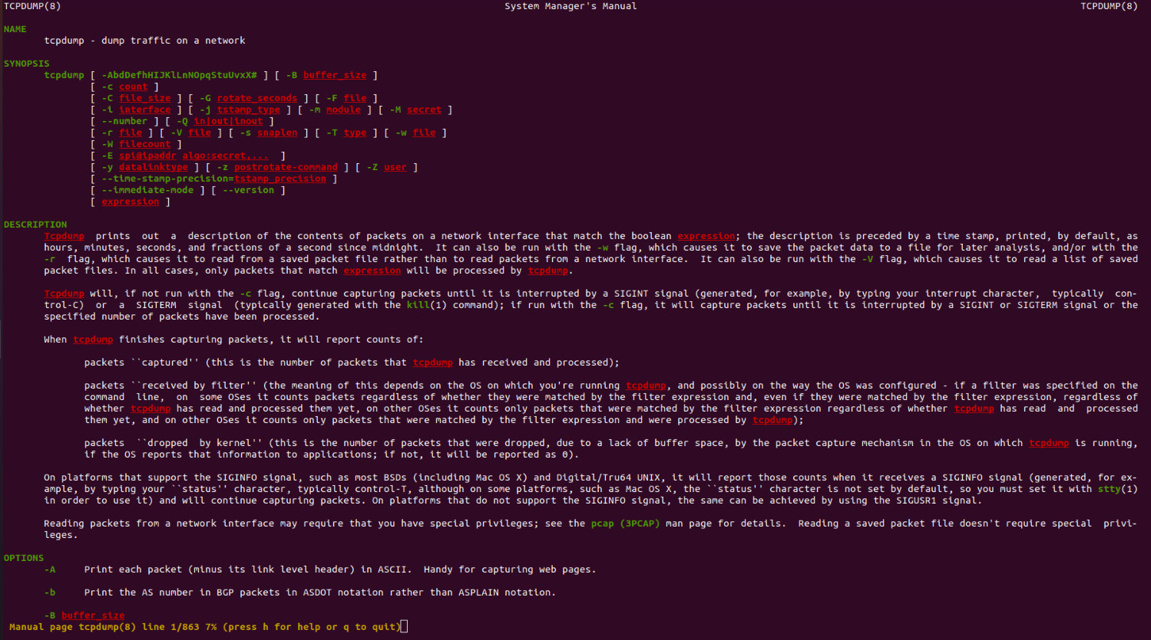
Looks really nice!

- Used tcpdump command like this:
tcpdump -# --time-stamp-precision=nano --packet-buffered -n -X
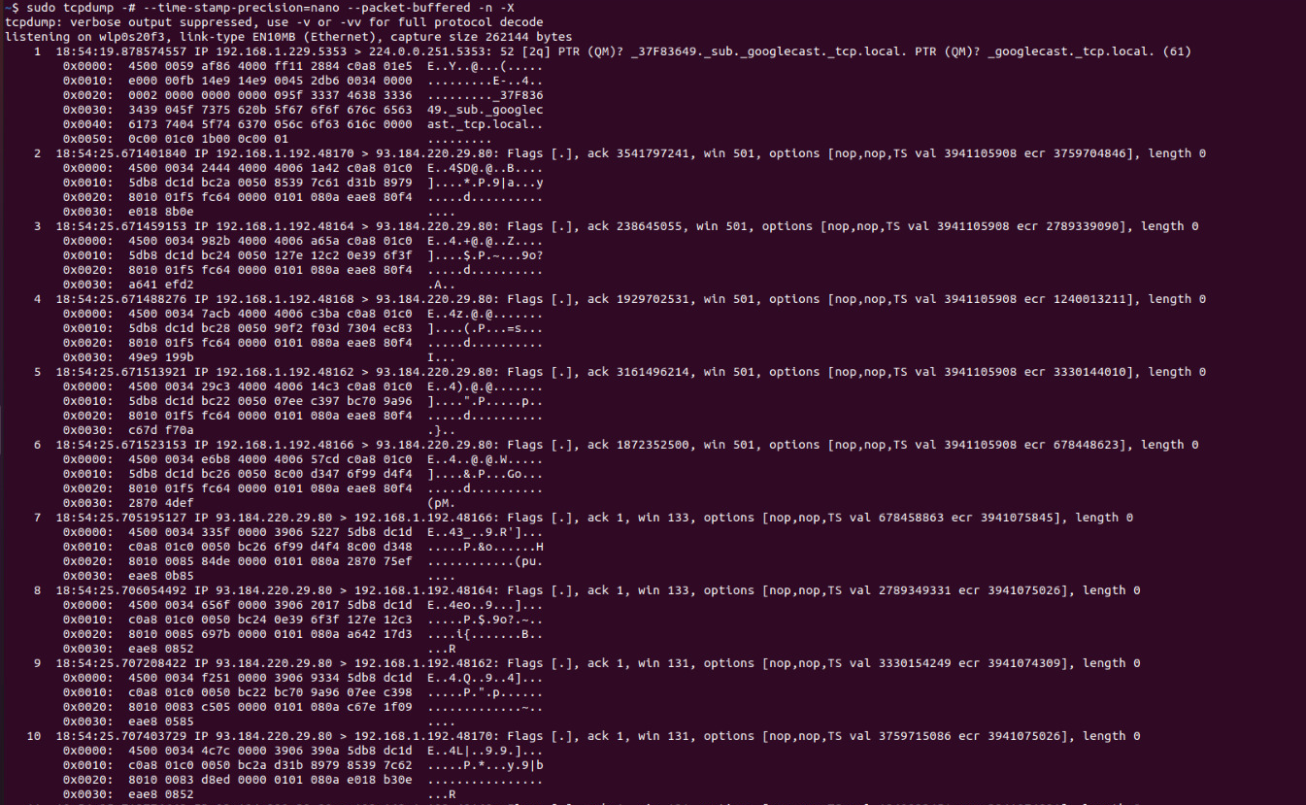
-# = print the packet number
--time-stamp-precision=nano = print the elapsed time in ns
--packet-buffered -X = print the content of each packet (without l2 header) in hex and ASCII
-n = do not resolve IP addresses to names

- (1) Used netstat -tulpen to find sockets created by root:
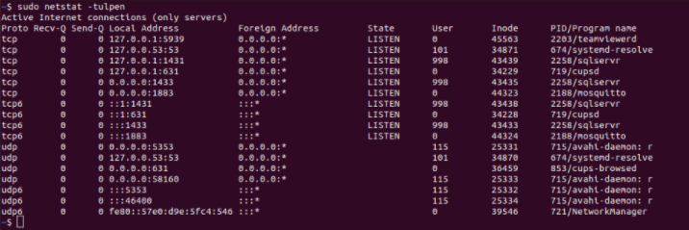

Then used iptables command:
iptables --append OUTPUT -p tcp --sport 49152:65535 --dport 5939 -j LOG --log-prefix "EP"
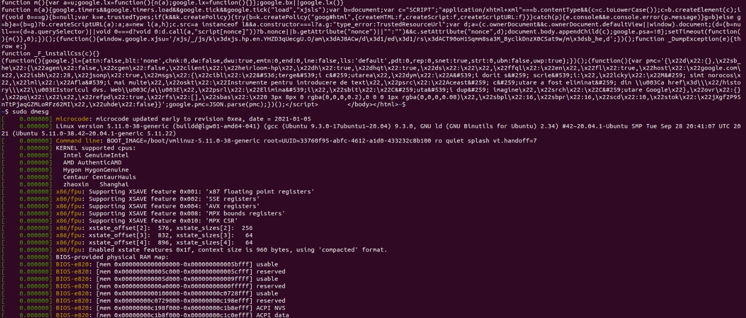
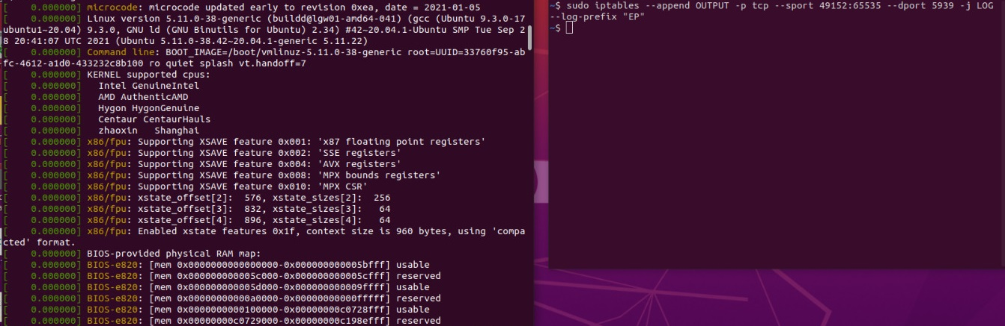
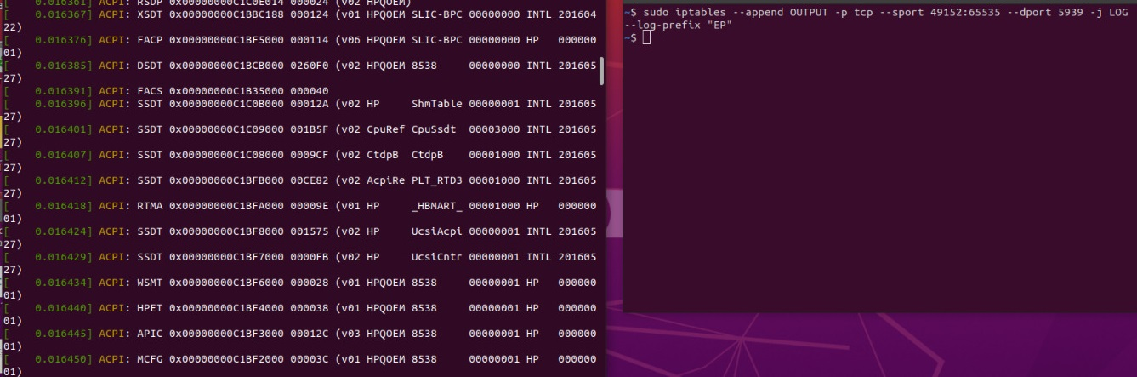
--append = -A = chain: OUTPUT
-p tcp = TCP protocol
-j LOG --log prefix = kernel logging of matched packets with “EP” prefix

Verified rules with sudo iptables -S OUTPUT:
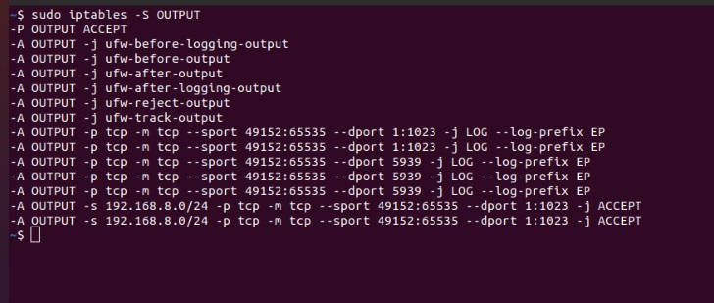

(2) Used iptables commands:
iptables -t mangle -A OUTPUT -p udp --dport 53 -j TTL --ttl-set 1
iptables -t mangle -A OUTPUT -p udp --dport 53 -j TTL --ttl-inc 255
-A OUTPUT = chain: OUTPUT
-p udp = UDP protocol
-j TTL --ttl-set 1 = set TTL to 1
-j TTL -ttl-inc 255 = increment TTL with 255

(3) iptables command is unable to catch a packet when the packet is null or invalid or not established.
Also, it is unable to do that when ports are open and incoming requests from those ports aren’t allowed (using ACCEPT rules).

Task 02. Network Exploration
- Added specified line in .bashrc:
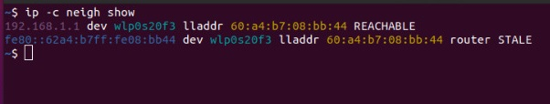
Looks nice! (x2)

Ran arp-scan command and then the script:
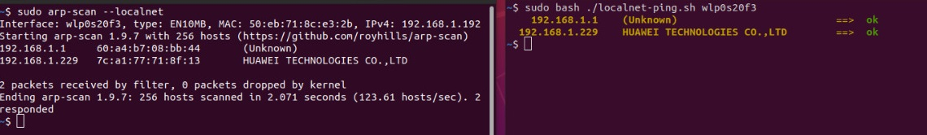

- nmap command:
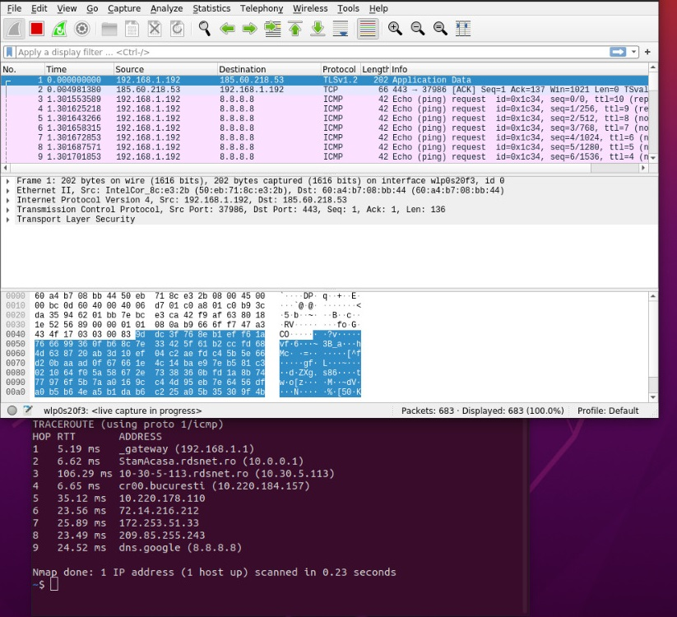

traceroute command:
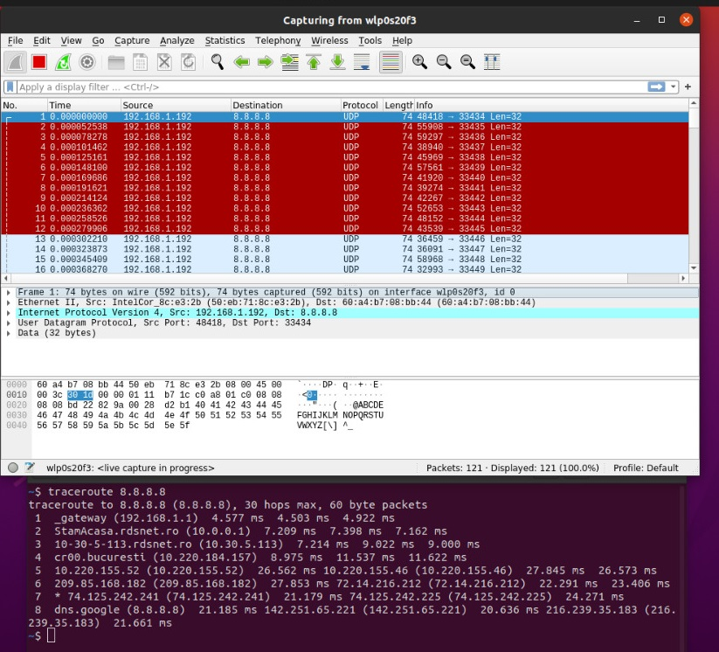

Differences:
-number of sent packets;
-traceroute gets a response from every hop
-nmap is static, while traceroute is dynamic

nmap command for UDP:
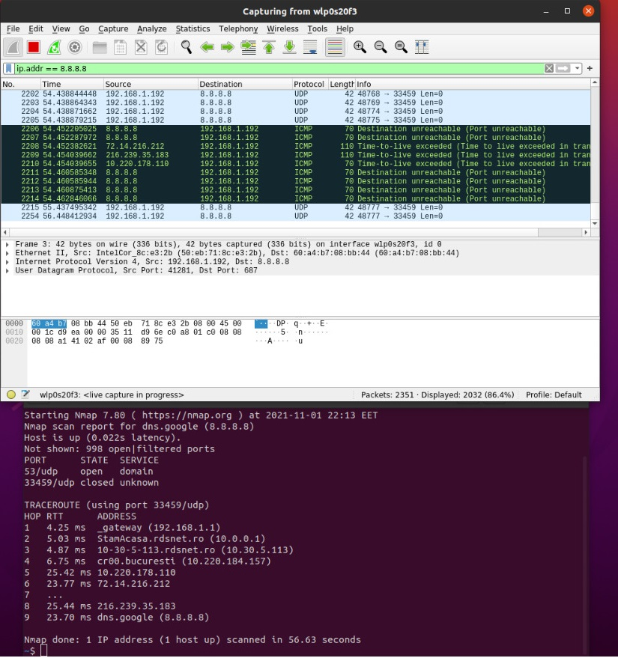
=> UDP ports discovered

Task 03. Protocol Options
- Ran iptables and root commands, then ping command to see transmitted packets:
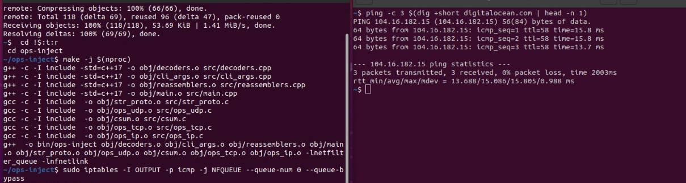

- Ran tcpdump command:
sudo tcpdump -U -i any -v -s0 -X >> log, then ping command. 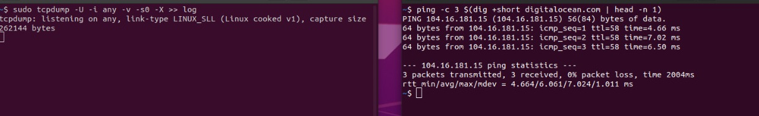
Printed log to see ICMP:
cat log | grep "ICMP"
22:43:15.549367 IP (tos 0x0, ttl 64, id 6715, offset 0, flags [DF], proto ICMP (1), length 84)
Iulia-LenovoG6 > 104.16.181.15: ICMP echo request, id 9, seq 1, length 64
22:43:15.553993 IP (tos 0x0, ttl 58, id 36931, offset 0, flags [none], proto ICMP (1), length 84)
104.16.181.15 > Iulia-LenovoG6: ICMP echo reply, id 9, seq 1, length 64
22:43:16.551514 IP (tos 0x0, ttl 64, id 6853, offset 0, flags [DF], proto ICMP (1), length 84)
Iulia-LenovoG6 > 104.16.181.15: ICMP echo request, id 9, seq 2, length 64
22:43:16.558457 IP (tos 0x0, ttl 58, id 56253, offset 0, flags [none], proto ICMP (1), length 84)
104.16.181.15 > Iulia-LenovoG6: ICMP echo reply, id 9, seq 2, length 64
22:43:17.553097 IP (tos 0x0, ttl 64, id 6954, offset 0, flags [DF], proto ICMP (1), length 84)
Iulia-LenovoG6 > 104.16.181.15: ICMP echo request, id 9, seq 3, length 64
22:43:17.559524 IP (tos 0x0, ttl 58, id 52211, offset 0, flags [none], proto ICMP (1), length 84)
104.16.181.15 > Iulia-LenovoG6: ICMP echo reply, id 9, seq 3, length 64
22:43:25.599387 IP6 (hlim 255, next-header ICMPv6 (58) payload length: 32) Iulia-LenovoG6 > _gateway: [icmp6 sum ok] ICMP6, neighbor solicitation, length 32, who has _gateway
22:43:25.602677 IP6 (hlim 255, next-header ICMPv6 (58) payload length: 24) _gateway > Iulia-LenovoG6: [icmp6 sum ok] ICMP6, neighbor advertisement, length 24, tgt is _gateway, Flags [router, solicited]
22:43:30.713443 IP6 (hlim 255, next-header ICMPv6 (58) payload length: 32) _gateway > Iulia-LenovoG6: [icmp6 sum ok] ICMP6, neighbor solicitation, length 32, who has Iulia-LenovoG6
22:43:30.713533 IP6 (hlim 255, next-header ICMPv6 (58) payload length: 24) Iulia-LenovoG6 > _gateway: [icmp6 sum ok] ICMP6, neighbor advertisement, length 24, tgt is Iulia-LenovoG6, Flags [solicited]

- Ran tcpdump command:
tcpdump -U -i any -v -s0 -X -w logs.pcap, then tshark command:
sudo tshark -r logs.pcap
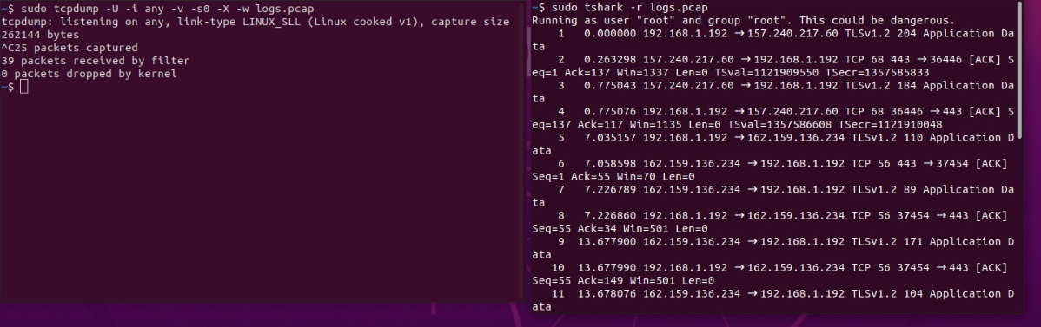
- Liked those colors more:
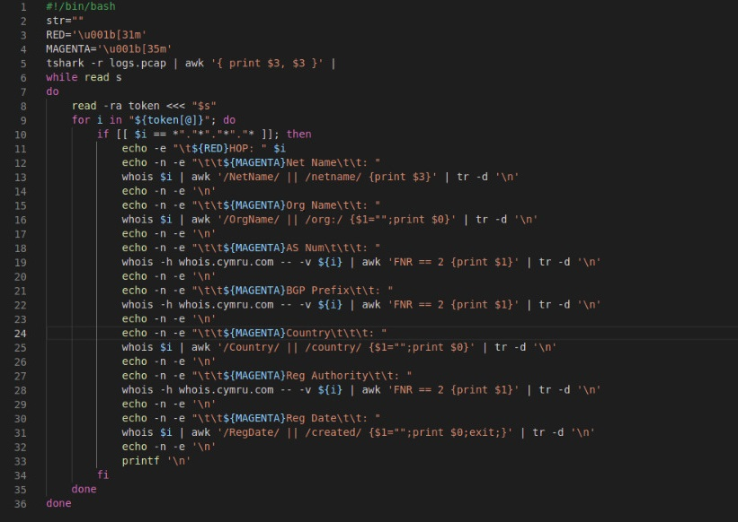
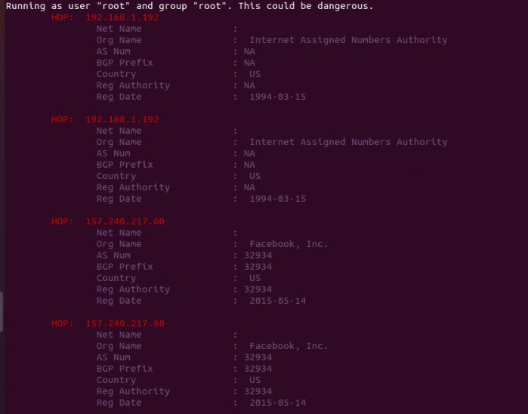

- Downloaded the pcap file and ran the script again:
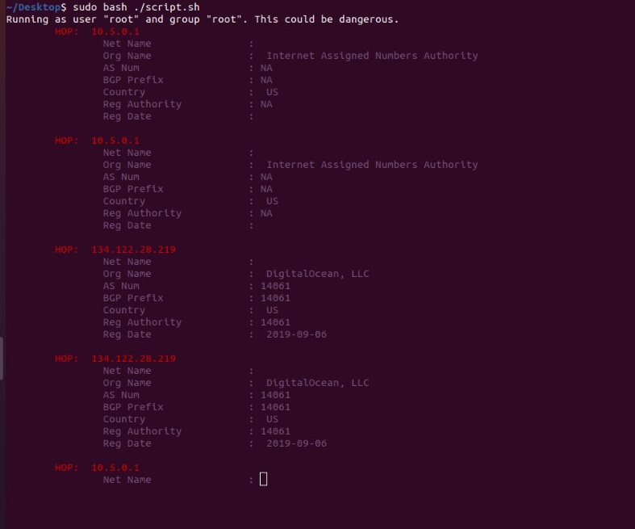

Tadaaaam! 🎉🎉🎉
Task 04. Feedback
